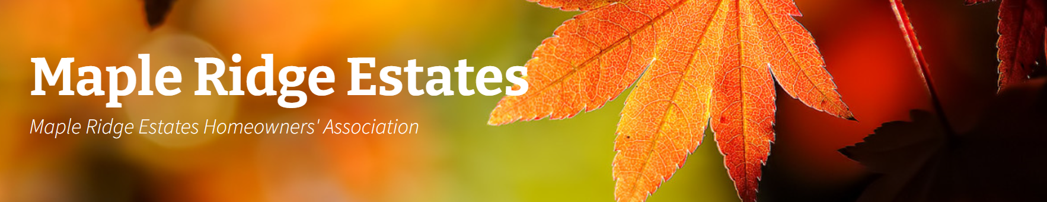
MAPLE RIDGE ESTATES HOA BOARD MEETING –
Date: 6/04/2025
Minutes
- Call to Order 7:10pm

- Attendance
Toni Pratt, Al, Jenn Shattuck, Pete Giere, Vivien Lu, Gigi Tiotuico,
Guest: Kristine Beaver
Absent: Liz Callaway
Approval of Prior Minutes – Minute approved

- Treasurer’s Report
Total April & May expense: $3,619.83, most of it was for Canber maintenance, Wix Website Hosting, and Cedar River. Total Checking/Saving balance as of May 31, 2025 is $38,405.66 w/ $25k reserve. Currently Available is $13,405.66. HOA dues collected from April & May are $18,429.5. In 2025, HOA Fees increased $6 (3%) to $221.00 per year.
- ACC
- The playground at the park needs new bark. We will begin by fluffing the existing bark to assess whether additional material is necessary. (Fluffing scheduled for Beautification Day – Saturday, June 7).
Remaining bark fluffing will be completed during the next meeting on Wednesday, August 6.
- Maintenance
- The mutt mitt dispenser and sign at the park entrance were intentionally removed. Al has reinstalled the dispenser and sign. This matter requires continued attention and monitoring.

- General Discussions
- South Entrance Monument: The letters on the monument have been stolen. Replacement letters need to be ordered at a cost of $400 per letter, with expected arrival by the end of June. It is suggested that warning signs reading "Under Surveillance" be posted at both entrances.

- Spring and Fall Cleanup: Cleanups are held twice a year.
  - Spring Cleanup: Both dumpsters will be for general household waste.
  - Fall Cleanup: Scheduled for October 10, 2025, with two separate dumpsters:
    - General household waste (located across from Jenn)
    - Yard waste (located across from 13906 SE 158th)
  - A flyer will be distributed a day before the event, noting: "The dumpster service is being funded by HOA funds, and it is based on the honor system. Please follow Republic Services' garbage rules, or we may not be able to continue offering this service next year."
  - We may offer a third dumpster for a fee, and a signup sheet for interested residents will be available. This will be mentioned during the Summer Picnic.
- Beautification Day (Saturday, June 7 at 10:00am): This is a great opportunity for the community to clean up and collect trash along 140th Street. Neighbors will be notified about monument upkeep and related expenses. The benefits include reducing crime, saving on cleaning costs, and increasing home values.
  - Items to bring include: wheelbarrow, utility cart, bark, gloves, garbage bags, shovel, rake, coffee, and donuts.
- Adult Family Home Zoning: The property is currently zoned as single-family residential. It has passed the city’s life safety inspection and is still in the registration process. A formal inquiry has been filed under state regulations, but registration is not yet complete.
- Summer Picnic (Saturday, August 23 at 11:30 AM | Ice Cream Truck at 12:00 PM):
  - Based on positive feedback from 2024, sandwiches and an ice cream truck will be provided again this year.
  - Suggested items to bring: Soda, sparkling water, bottled water, juice, beer/seltzer.
  - Additional Items: Raffle (organized by Gigi), banner, stickers/markers for name tags.

- Meeting Adjourned - 8:14pm
Board meetings will be held every 1st Wednesday of every other month in the evening. A reminder will be sent out.
    - August 6th 7:00pm
    - October 1st 7:00pm
    - December 3rd 7:00pm
Next meeting – 6/04/2025. Location: Park

