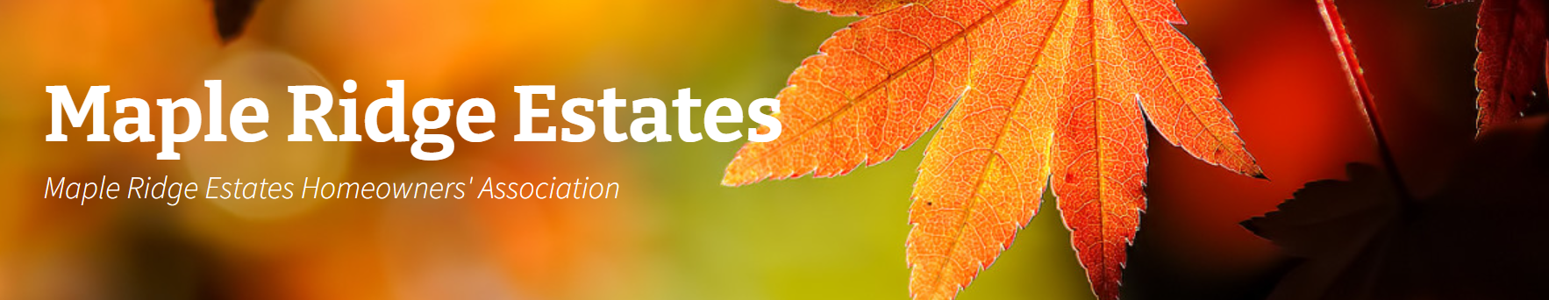
MAPLE RIDGE ESTATES HOA BOARD MEETING –
Date: 10/01/2025
Minutes
- Call to Order 7:05pm

- Attendance
Toni Pratt, Al, Jenn Shattuck, Pete Giere, Vivien Lu, Gigi Tiotuico, Tony Lam (New Member)
Guest: Steve Kearns
Absent: Liz Callaway, Kristine Beaver, Bailee
Approval of Prior Minutes – Minute approved

- Treasurer’s Report
Total August & September expense: $4,977.41, most of it was for Canber maintenance, irrigation repair, annual picnic, and Cedar River. Total Checking/Saving balance as of September 30, 2025 is $36,602.13 w/ $25k reserve. Currently Available is $11,602.13. HOA dues collected from August & September are $663. In 2025, HOA Fees increased $6 (3%) to $221.00 per year.
- ACC
- Playground Bark: The bark at the park playground is in need of replacement. The board will evaluate the condition and options in early spring.
- Mutt Mitt Stations: There are currently three mutt mitt stations. Continued monitoring is needed due to instances of intentional theft; however, additional measures have helped reduce the problem, and activity has stabilized.
- Maintenance
- Monument Signage: The letters on the monument have been stolen multiple times. The Board is considering ordering a custom, durable metal plate sign as a simpler and more vandal-resistant solution.
- Mutt Mitts- Currently, there are three locations for mutt mitts. Continued attention and monitoring are needed regarding people intentionally stealing mutt mitts.
- Lighting – Common Areas: Two light poles are out and another is flickering. PSE has been contacted for repair.

- General Discussions

- Fall Cleanup:
  - Scheduled for October 24, 2025, with two separate dumpsters:
    - General household waste (located across from 15437 139th Ave SE)
    - General household waste (located across from 13906 SE 158th)
- Adult Family Home Zoning: The property is currently zoned as single-family residential. It has passed the city’s life safety inspection and is still in the registration process. A formal inquiry has been filed under state regulations, but registration is not yet complete.
- Properties on 139th: Two properties on 139th have blackberry bushes encroaching onto the sidewalk. First notices have been issued to the homeowners.
- Property on 158th: The homeowner submitted a request to paint the body, trim, and gutters all the same blue color. A response was issued citing the CC&Rs, which require variation and do not permit all elements to be painted the same color. The Board is awaiting a revised color submission from the homeowner.
- HOA Member Update: Al is stepping down from the ACC after three years of service. Tony Lam will assume responsibilities on the committee. The Board thanks Al for his dedicated service. Bailee has joined the HOA and is expected to attend the December meeting.

- Meeting Adjourned - 8:03pm
Board meetings will be held every 1st Wednesday of every other month in the evening. A reminder will be sent out.
    - December 3rd 7:00pm
    - February 4th 7:00pm
    - April 1st 7:00pm
    - June 3rd 7:00pm
    - August 5th 7:00pm
    - October 7th 7:00pm
    - December 2nd 7:00pm

Next meeting – 12/03/2025. Location: TBD

