MAPLE RIDGE ESTATES HOA ANNUAL BOARD MEETING – 02/03/2022
Minutes
- Call to Order 7:06pm

- Attendance
Present: Michael, Pete, Gigi, Toni,
Absent: Jess, Liz

- Treasurer’s Report

- Total Income as of 12/31/2021 - $32,560 ($25k emergency reserve and $7,500 available balance)
- 90% of 2021 dues are paid
- December expense:
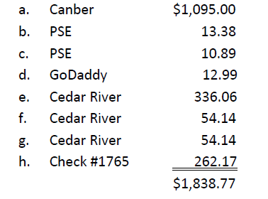
- Dues increased from $198 to $203 effective 1/1/2022

- Committee Report, Maintenance and ACC

- Sidewalk repair on 158th street. Gigi spoke to [REDACTED] and asked for permission to do the repair on her front yard. [REDACTED] agreed but won’t pay for it. Camber’s estimate is $1,750 + tax. Camber will install approximately 30’ French drain to drywell, to divert surface water. Approved by the Board.
  - Robert will coordinate with Camber and Gigi will inform [REDACTED] of the date/time of the repair
- Camber estimate of the Sprinklers on 158th and 156th monuments is $4,500 + tax. Robert will confirm with Camber if this includes the park. Asked Camber to do a full check of the entire sprinkler system
- Need to put a note on people’s doors to take down non-permanent holiday lights
- Vehicles with expired license plate – call the city
- Board will review together what to put on the annual HOA flyer, e.g. need board members/volunteers, annual picnic. Board will meet on April 7th.
- ACC requests/permission go directly to Bob. Need to change that. MRE’s online presence and ways of communications need work. Website is fine and updated by Liz. The Board will look into outsourcing the creation and maintenance of MRE’s online presence and omnichannel communication, will scrap the existing system . Toni will talk to her niece or friend…maybe submit a proposal
- Michael will find out if there are current requests sent to Bob

- General Discussions:

- Picnic Planning – Picnic and Annual HOA meeting date: August 20, 2022 Saturday
  - HOA Annual meeting will be combined with the picnic
  - Announcement will be included on the annual HOA flyer. Board will meet to go over it together at the April 7th meeting.
  - Board will discuss the details such as food (food truck?) and any housekeeping items at the June meeting
  - Gigi can create a reminder flyer and put in the mailbox slots in June/July.
  - Final review and last-minute items will be discussed at the August meeting

- Meeting Adjourned at 8:00PM

Board meeting will be held every 1st Thursday of every other month in the evening. Gigi will send out reminder.
    - February 4th 7:00pm – Thursday
    - April 7th 7:00 pm – Thursday
    - June 2nd 7:00pm – Thursday
    - August 4th 7:00pm – Thursday
    - August 20th time TBD – combined with Annual Picnic

